1) Hoisting
it means we can use a function even before its initialization and block of code , the java script engine allocates memory to it at the top of the program , this will only work for traditional functions and does not work for function expression or arrow functions ( the engine hoists the variable names but it will be undefined until the code reaches that part) so if you use it for expression or arrow functions you will get reference error or type error

2)Call back
callback means passing an function as an argument to another function that implies that this function which is passed as an argument should only be executed after the main function , these are usually used in asynchronous programming so that this function can be executed after a specific functionality is executed
eg :
function greet(name){
return `Welcome ${name}`
}

function processName(name,callback) {
let userName = name ;
return callback(name)
}

console.log(processName("Tharnish",greet))

here even the call back function (greet) itself returns the value but it will not be printed in the console because A return value only goes one level up — not automatically to the top.

call Back hell :
Multiple callbacks are nested inside each other, making code hard to read, messy, and difficult to maintain . Callback hell is a situation where multiple nested callbacks make code difficult to read, debug, and maintain.

Call() Method
call method lets us set the value of this manually by ourself when calling a function ,
eg . functionName.call(thisArg, arg1, arg2, ...) we use it after a function name(.call()) the first argument inside the call is the ‘This argument’ then the following arguments are normal function arguments
eg const person = {name:"Tharnish" , role:"Trainee"}

function greet(age , gender){
return `Welcome ${this.name} ${this.role} ${age} ${gender}`
}

console.log(greet.call(person , 20 , "Male"))

this method is used to call the function immediately and also set ‘this’

apply() Method
this method is very similar to call() method the only difference is how the arguments are passed in call method the arguments are passed separated by commas but here all the function arguments are inside an array eg function.apply(argThis,[arg1,arg2…]) apart from this everything else is same to call()

Bind() function
The bind function is used to wrap a function and an object(this) into a new function and we can use that new function when we want
Eg const newFunction = originalFunction.bind(thisArg, arg1, arg2, ...)
You can immediately pass the arguments for the the function we are binding like above or can even pass It later
Eg const newFunction = ogFunction.bind(thisArg);
Later newFunction(arg1,arg2…)

Key Points between call(),apply() and bind()

1. Core Concept
All three methods (call, apply, bind) are used to control the value of this in a function.

2. Definitions
call()
Invokes the function immediately and allows you to set this explicitly.
apply()
Invokes the function immediately and allows you to set this, but arguments are passed as an array.

bind()
Does not invoke the function immediately. Instead, it returns a new function with this permanently bound.

Syntax

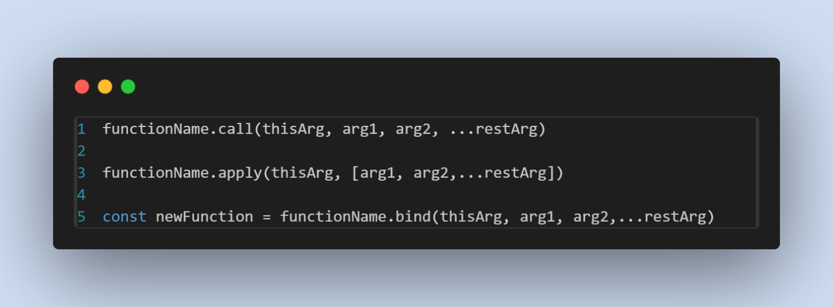

DOM

target element using getElementByid and use addEventListener(event,callback) inside the callback function you can reference a function without () or declare a anonymous function inside or use arrow functions inside

the (event) object is the object that is created automatically when an event happens it stores all the imformation about the events , we use it in onclicklisteners to change styling or text of a element like eg event.target.style.background = “black” , here instead of passing the event object inside the function we can diretly do that with eg this.style.background = “white” and this keyword cannot be used with arrow functions

the selectors in js are
getElementById selects one element with specifies id
getElementByTagName selects all the elements with the specified tag (returns in a node list)
getElementsByClassName selects all the elements with the specified class
querySelector it acts like a css selector for id use #id for class use .class and allows things like “ul li” , p.message etc…
querySelectorAll same like querySelector but selects all the elements

to get the parent node of your element use .parentNode
eg – let txt = document.getElementById(“#txt”)
txt.parentNode
txt.nextSibling(this also counts spaces as sibling)
txt.nextElementSibling(this only considers elements as siblings)

Creating Html Elements using JS
Use let doc = document.createElement(‘element’)
Add html using doc.innerHtml = “<p></p>”
After that add it to the webpage using document.body.appendChild(doc)

Eg adding a li to a ul
Const list = document.getElemenById(‘menu’)
Const li = document.createElement(‘li’)
li.innerHtml = “content”
list.appendChild(li)

here appendChild can append only one to append multiple elements inside a Element use append method ,
after()
this method is used to add a element after another element and this also takes any number of arguments

preppend()
this similar to append() but adds at the top inside the element

insertAdjacentHTML(position , value to insert) the position can be before begin , after begin , before end and after end

replaceChild(oldChild,newChild)
used to replace old child with new one

cloneNode()
used to create a duplicate of a element inside that pass true to create duplicates of its childrens too by default it is false

removeChild(childNode)
used to remove a child

insertBefore(newNode,existingNode) :
before the existing node the new node will be added

.attributes
Can be used to find attributes of a element
getAttribute() can be used to get value of a specific attribute
setAttribute can be used to set a attribute()
hasAttribute() , removeAttribute()

we can add styling using element.style.property = value
another way is element.style.cssText = “property:value”

window.getComputerStyle(element) to get all its styles

.className returns all the classes in the element and we can also add new class
.classList returns collection of list in the element(similar to array) it is used to add and remove class from a element to add .classList.add(class1,class2…..classn) to remove - remove() , to replace – replace(existingClass ,newClass ) , .contains to check if a class exists

Element.classList.toggle(class) (important)
this function removes a class if it exists in the element and adds the class if it does not exist in the element

JavaScript Events
Important
When an Event Occurs the web Browser passes a event object to the Event handler that event object contains all the information about the event

Inside the Event Handler “this” leyword refers to the target in which the event occurred

Two Event Models
- Event Bubbling
The Event Flows from most Specific element to least specific element

- Event Capturing
Event flows from least specific element to most Specific Element

removeEventListener(event,function) is used to remove a event listener

Events
mouseMove
Event fires repeatedly when you move the mouse Cursor Around the Element
mouseDown:
When you press the Mouse Button (any button) on the element
mouseUp :
it triggers when you release the Mouse Button on the Element

mouseOver :
Event fires when the cursor moves from outside the element to inside the Boundaries of the Element

mouseOut:
when the mouse cursor moves from inside the Element to outside the Element

keyDown :
Triggers when you press a key on keyboard and fires repeatedly when you hold the key
keyUp:
fires when you release a key on key board

keypress(deprecated):
occurs when you press a character on keyboard like a,b,c . it fires repeatedly while you hold the key , this is deprecated use keyDown

scroll :
occurs when you scroll the page

Asynchronous Programming
async :
async enables a function to return a promise
await :
makes a async function wait for a promise
Promise :
A promise is a object that holds future value of a async operation

It has 3 states
1.pending
2.fulfilled
3.rejected

